**Ideation Phase**

**Define the Problem Statements**

|  |  |
| --- | --- |
| Date | 19 September 2022 |
| Team ID | PNT2022TMID27348 |
| Project Name | Project -Plasma Donor Application |
| Maximum Marks | 2 Marks |

**Customer Problem Statement Template:**

Plasma therapy is an experimental approach to treat corona-positive patients and help them recover. This plasma therapy is considered to be safe & promising. A person who has recovered from Covid can donate his/her plasma to a person who is infected with the coronavirus.

Our ultimate aim is to connect the donors & the patients by an online application. By using this application, the users can either raise a request for plasma donation or requirement .This system is used if anyone needs a Plasma Donor. This system comprises of Admin and User where both can request for a Plasma. In this system there is something called an active user, which means the user is an Active member of the App and has recovered from Covid 19, only such people are recommended here for Plasma Donation. Both parties can Accept or Reject the request. User has to Upload a Covid Negative report to be able to Donate Plasma.

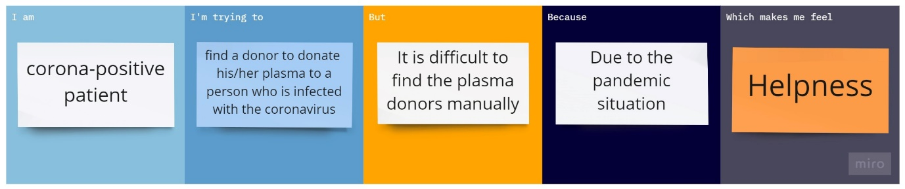

Reference: <https://miro.com/templates/customer-problem-statement/>